AI-DRIVEN MARINE OIL SPILL DETECTION, SOURCE ATTRIBUTION, AND SPATIOTEMPORAL RISK ASSESSMENT USING SAR,AIS, GIS, AND ENVIRONMENTAL DATA

Simon Jaques Mascarenhas J, Nitish Narayanan G

Department of Electronics and Communication Engineering
Chennai Institute of Technology (Autonomous), Chennai, India

ABSTRACT
Marine oil spills can spread rapidly across large oceanic regions, making early detection and monitoring challenging. This paper presents OceanSight AI, an integrated marine oil-spill monitoring framework combining Synthetic Aperture Radar (SAR), deep learning, image processing, Geographic Information System (GIS) mapping, Automatic Identification System (AIS) data, and environmental information. A MobileNetV2-based binary classifier is developed to distinguish between Oil Spill and No Oil Spill images. The dataset contains 5,548 labelled images, consisting of 3,695 No Oil Spill and 1,843 Oil Spill samples. The model uses an input size of 224 × 224 × 3 and achieved approximately 93% training accuracy during development. Following classification, OpenCV-based image processing is used to obtain an approximate candidate spill region for visualization. The detected event can then be associated with geographic information, nearby vessel activity, and environmental conditions such as wind and ocean currents. AIS information is used for possible source correlation rather than definitive attribution, while environmental data provides contextual information for possible spill movement. The proposed system focuses on integrating multiple sources of evidence into a unified decision-support workflow. Further independent validation and improved segmentation are required before operational deployment.
Keywords— Marine Oil Spill, SAR, Sentinel-1, MobileNetV2, Deep Learning, GIS, AIS, Remote Sensing.

I. INTRODUCTION
Marine oil spills are a major environmental concern because released oil can affect marine ecosystems, coastal areas, fisheries, and maritime activities. Since spills can spread over large and continuously changing regions, timely detection and monitoring are important for supporting response activities.
Satellite remote sensing provides a practical method for observing large marine areas. Synthetic Aperture Radar (SAR) is particularly useful because radar observations can be obtained during both day and night and are less dependent on visible-light conditions. Sentinel-1 SAR imagery can therefore provide useful observations for marine surface monitoring.
However, identifying oil spills from SAR imagery is challenging because oil signatures can resemble naturally dark ocean regions and other SAR look-alikes. Manual inspection of large quantities of imagery can also be time-consuming. Deep-learning models can assist by automatically screening images for patterns associated with oil spills.
OceanSight AI extends this image-classification approach by combining it with geographical and contextual information. The system uses a MobileNetV2 model to classify SAR images into Oil Spill and No Oil Spill categories. A subsequent image-processing stage provides an approximate candidate region, which can then be visualized using GIS.
The system is additionally designed to incorporate AIS vessel information and environmental conditions. Vessel position, speed, heading, identity, and timestamps can provide supporting information when examining possible sources. Wind and ocean-current information can provide context for interpreting possible spill movement. These sources are treated as supporting evidence rather than definitive proof.
The primary objectives of OceanSight AI are to develop an AI-based oil-spill detection workflow, utilize SAR imagery, classify potential spills using MobileNetV2, visualize detected regions geographically, and integrate vessel and environmental information into a common monitoring interface. The project therefore focuses on integration of multiple evidence sources rather than claiming a new segmentation or source-attribution algorithm.

II. RELATED WORK
Research on marine oil-spill detection has increasingly focused on satellite remote sensing and machine learning. SAR imagery has been widely investigated because it provides wide-area marine observations and can identify surface features associated with oil-covered regions.
Bianchi et al. investigated large-scale oil-spill detection and categorization using deep learning on SAR imagery. Other studies have developed deep-learning frameworks for SAR-based oil-spill detection and semantic segmentation. These approaches demonstrate the potential of automated methods for reducing the dependence on manual interpretation.
Research has also progressed toward more advanced segmentation techniques capable of identifying spill boundaries at pixel level. Such methods are useful when accurate estimation of spill extent is required. However, they generally require specialized labelled datasets and greater computational complexity.
Beyond image analysis, multi-source approaches have investigated vessel tracking and environmental information. AIS data can provide vessel movement histories around detected events, while environmental modelling can assist in understanding possible spill trajectories.
OceanSight AI combines these concepts into a single workflow. Its current machine-learning component performs image-level binary classification, while OpenCV-based processing provides an approximate candidate region. The broader system then connects the detection to GIS, AIS, and environmental information.

TABLE I — RELATED TECHNOLOGIES
Technology | Role
Sentinel-1 SAR | Marine surface observation
MobileNetV2 | Oil-spill classification
OpenCV | Candidate-region extraction
GIS | Spatial visualization
AIS | Vessel context
Wind/Current Data | Movement interpretation

III. PROPOSED OCEANSIGHT AI SYSTEM

A. System Architecture
SAR Image → Preprocessing → MobileNetV2 → Classification → Candidate Region → GIS → AIS/Environmental Analysis
The architecture separates the AI classification stage from subsequent image-processing and contextual-analysis stages. This allows each component to perform a specific function within the overall monitoring workflow.
The system supports both manually supplied imagery and a planned automatic mode in which suitable satellite observations can be retrieved for a selected monitoring region.

B. SAR Data
Sentinel-1 SAR imagery forms the primary remote-sensing input. The system is designed to obtain satellite data through the Copernicus Data Space ecosystem.
SAR provides an observation of the marine surface from which potential oil-spill signatures can be identified. The input image is prepared before classification to ensure that it matches the model's required dimensions.
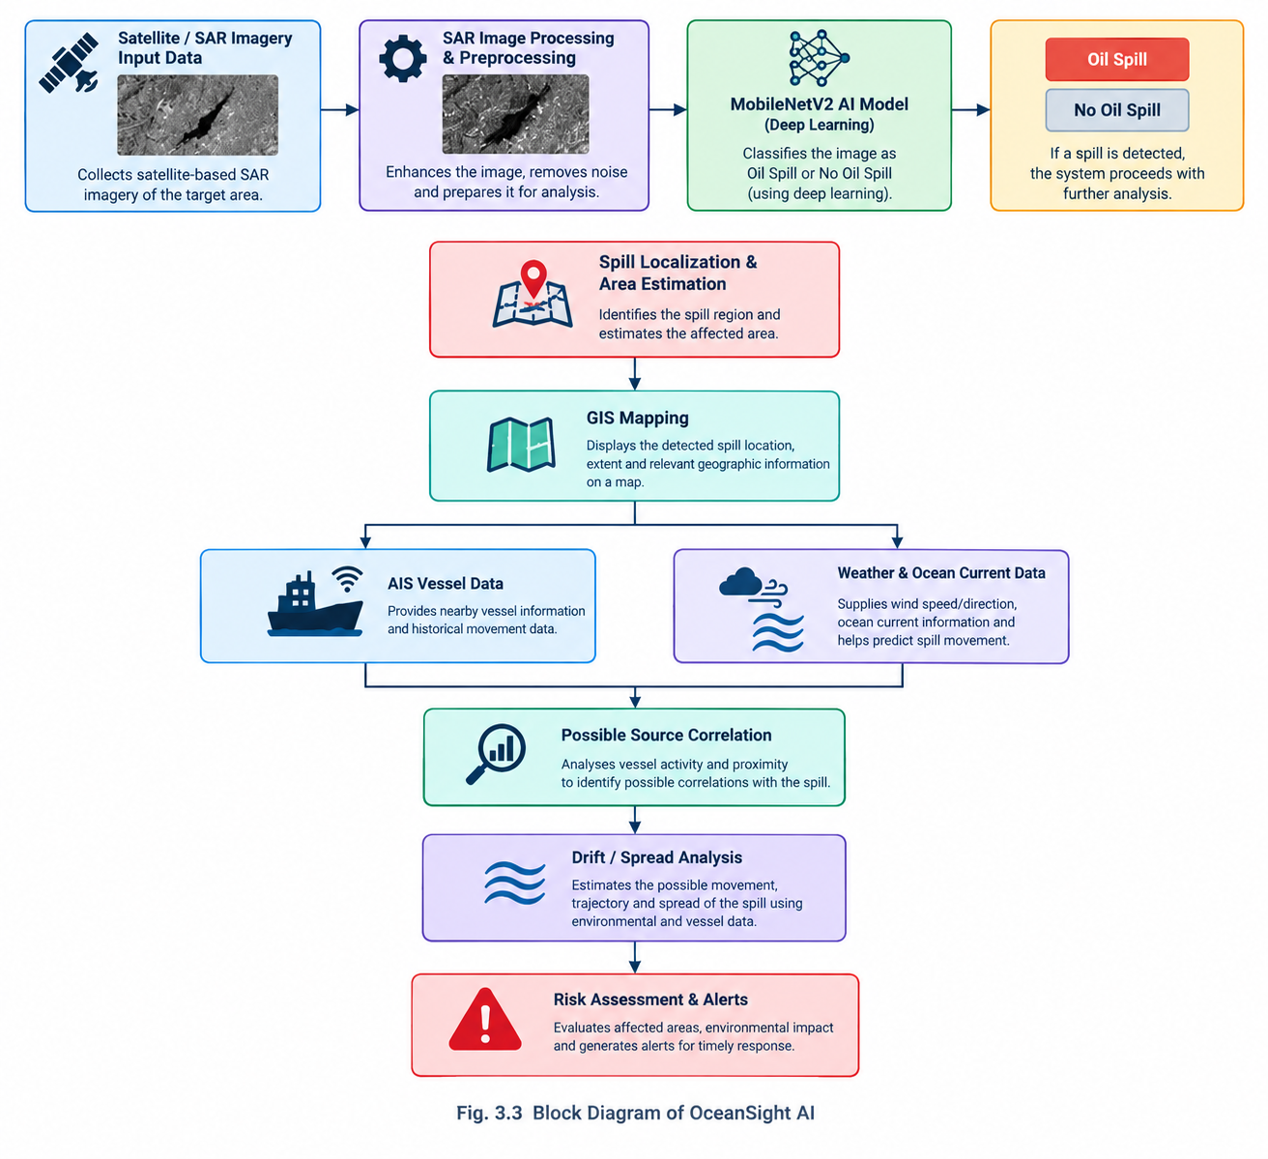

C. Dataset Preparation
The developed classification dataset contains 5,548 labelled images.

TABLE II — DATASET DISTRIBUTION
Class | Images | Class Weight
No Oil Spill | 3,695 | 0.7504
Oil Spill | 1,843 | 1.4985
Total | 5,548 | —
The images are processed at 224 × 224 × 3 resolution. Because the number of images in the two classes is unequal, class weights are incorporated during training.
Data augmentation is also used during model development to expose the model to variations in image appearance.

D. MobileNetV2 Classification
MobileNetV2 is used as the primary deep-learning architecture for binary classification. Its relatively lightweight structure makes it suitable for integrating image-based inference into a broader application.
The model receives the prepared image and produces a probability associated with the Oil Spill class.
The classification process is:
Input Image → Feature Extraction → Learned Representation → Classification → Probability
The two output classes are:
- Oil Spill
- No Oil Spill
The trained model is saved as oil_spill_mobilenetv2.keras and used during inference.

E. Candidate Region Extraction
MobileNetV2 provides image-level classification and does not perform pixel-level segmentation.
For an image classified as a potential Oil Spill, OpenCV-based processing can be applied to identify an approximate suspicious region. Thresholding and contour-based operations can be used to generate a candidate boundary for visualization.
This distinction is important because the resulting boundary is only an approximate candidate region and should not be interpreted as an accurately segmented spill perimeter.

F. GIS Integration
GIS provides the spatial component of OceanSight AI. Detected events can be associated with geographical coordinates and displayed together with relevant map layers.
The GIS interface allows the analyst to relate the potential spill to coastlines, marine regions, and other available geographic information.
[FIGURE 4 — OceanSight GIS interface]

G. AIS and Environmental Information
AIS data provides contextual information about vessels operating near a detected event. Relevant parameters include vessel identity, position, speed, heading, and timestamps.
This information can be used to examine whether vessel movement is spatially or temporally associated with a detected spill. However, proximity to a spill does not establish that a particular vessel caused it.
Environmental information, including wind and ocean-current conditions, can additionally be considered when interpreting possible spill movement.
Thus, OceanSight AI treats AIS and environmental information as supporting evidence for investigation rather than definitive attribution.

IV. SYSTEM IMPLEMENTATION
The OceanSight AI prototype uses a combination of machine-learning, image-processing, backend, and web technologies.

TABLE III — SOFTWARE COMPONENTS
Component | Technology | Function
ML Model | MobileNetV2 | Classification
ML Framework | TensorFlow/Keras | Training & inference
Image Processing | OpenCV | Candidate region
Numerical Processing | NumPy | Array operations
Backend | FastAPI | API and processing
Frontend | HTML/JavaScript | User interface
Mapping | Leaflet | GIS visualization
The machine-learning model is developed using Python, TensorFlow/Keras, and Google Colab. The trained model is integrated into the FastAPI backend. The backend receives analysis requests, prepares input imagery, performs inference, and returns the prediction results to the frontend. OpenCV processing can subsequently be applied to potential spill images.
The web interface provides a common platform for displaying classification results and geographic information.
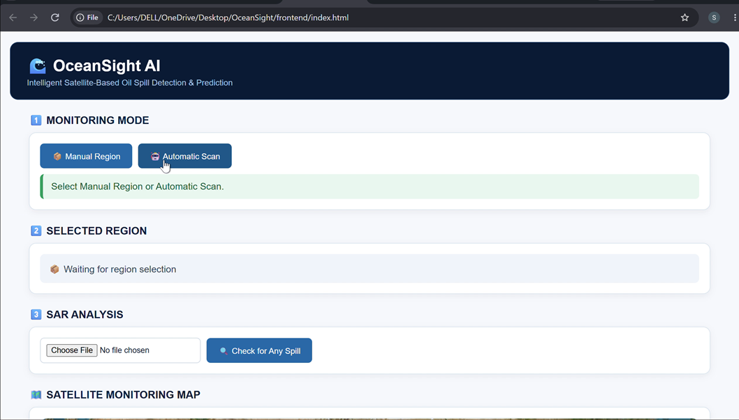
The system supports two operating modes. Manual mode allows users to upload or select imagery for testing and demonstration. Automatic mode is intended to retrieve suitable satellite observations for a selected monitoring region and process them through the same workflow.

V. RESULTS AND DISCUSSION

A. Model Development
The MobileNetV2 classifier was trained using the 5,548-image dataset.

TABLE IV — MODEL DEVELOPMENT RESULT
Parameter | Result
Dataset | 5,548 images
Input | 224 × 224 × 3
Architecture | MobileNetV2
Classes | 2
Training Accuracy | ≈93%
The model achieved approximately 93% training accuracy during development.
This result indicates that the model learned a distinction between the two labelled classes within the development data. However, it does not establish performance on unseen satellite scenes. Independent validation is required to measure generalization.
Factors such as geographical variation, sea state, acquisition conditions, sensor characteristics, and SAR look-alikes can influence performance.

B. SAR Detection and Candidate Region
After classification, an Oil Spill prediction can be passed to the OpenCV processing stage.
The resulting candidate boundary provides an additional visual indication of the region associated with the classification. This is useful for presenting the result to a human analyst instead of providing only a binary class label.

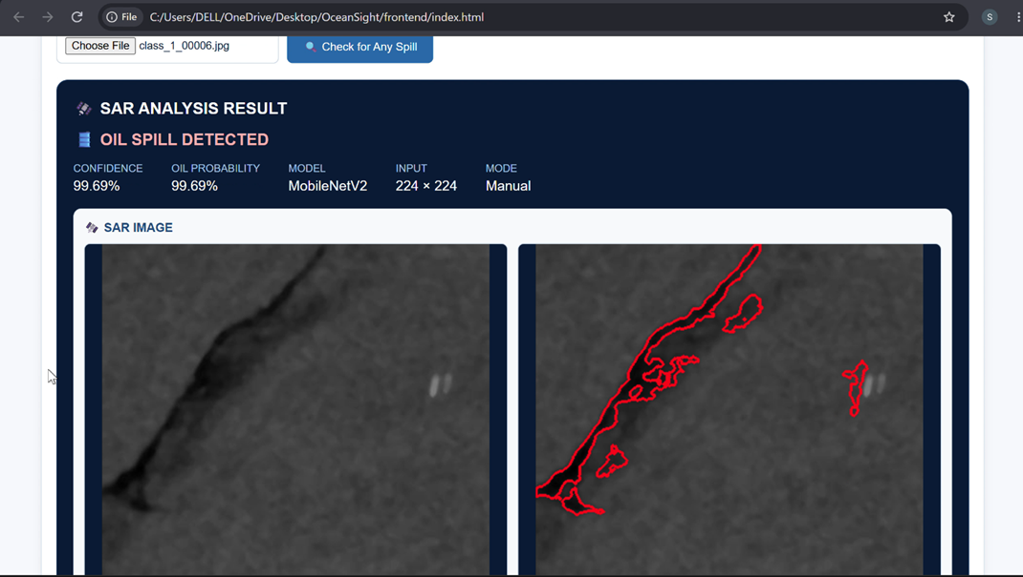

C. Integrated Monitoring
The main result of OceanSight AI is the integration of multiple analysis stages around a detected event.

TABLE V — INTEGRATED SYSTEM OUTPUT
Module | Output
SAR | Marine surface observation
AI | Potential oil-spill classification
OpenCV | Approximate candidate region
GIS | Geographic representation
AIS | Possible vessel correlation
Environment | Movement context
Drift Analysis | Possible spread interpretation
Instead of stopping after image classification, the workflow can continue toward geographic representation, vessel analysis, and environmental interpretation.
This provides a more complete monitoring workflow than an isolated image classifier.

D. Limitations
The current implementation has several limitations.
First, the reported approximately 93% result is training accuracy rather than independent test accuracy. Therefore, further validation is necessary before making claims about real-world detection performance.
Second, SAR images contain naturally dark regions and other look-alikes that can be confused with oil-spill signatures.
Third, the current localization method provides only an approximate candidate boundary rather than pixel-level semantic segmentation.
Fourth, AIS information can identify nearby vessel activity but cannot independently establish responsibility for a spill.
Finally, automatic satellite, AIS, and environmental-data retrieval depends on external services, network availability, credentials, data coverage, and API limitations.

VI. FUTURE ENHANCEMENTS
Future development of OceanSight AI can focus on improving both detection accuracy and operational capability.
A dedicated semantic-segmentation model, such as U-Net, could replace the current approximate boundary extraction and provide pixel-level spill localization.
The dataset can also be expanded using geographically diverse SAR scenes to improve robustness across different marine environments.
Multi-temporal Sentinel-1 imagery could be incorporated to observe changes in a detected spill over time. AIS trajectory information can be further combined with timestamps and spatial relationships to support more detailed source-correlation analysis.
Environmental modelling can also be improved by incorporating higher-resolution wind and ocean-current information for more detailed drift estimation.
Finally, the system can be extended into a real-time monitoring platform capable of automatically retrieving new satellite observations, performing inference, updating GIS layers, and generating alerts.

VII. CONCLUSION
OceanSight AI presents an integrated approach to marine oil-spill monitoring by combining SAR imagery, MobileNetV2 deep learning, OpenCV image processing, GIS, AIS, and environmental information.
The developed MobileNetV2 classifier uses 5,548 labelled images and achieved approximately 93% training accuracy during development. The classification stage is complemented by approximate candidate-region extraction and geographical visualization.
The system demonstrates how multiple information sources can be organized around a potential spill event rather than treating detection as an isolated classification task. AIS and environmental information provide additional context for investigating possible sources and movement.
The current prototype should be considered a decision-support system, and independent validation, improved segmentation, broader datasets, and reliable live-data integration are required before operational deployment.

REFERENCES
- Bianchi, F. M., Espeseth, M. M., & Borch, N. (2020). Large-scale detection and categorization of oil spills from SAR images with deep learning. Remote Sensing, 12(14), 2260. https://doi.org/10.3390/rs12142260
- Shaban, M., Salim, R., Abu Khalifeh, H., Khelifi, A., Shalaby, A., El-Mashad, S., Mahmoud, A., Ghazal, M., & El-Baz, A. (2021). A deep-learning framework for the detection of oil spills from SAR data. Sensors, 21(7), 2351. https://doi.org/10.3390/s21072351
- Hasimoto-Beltran, R., Canul-Ku, M., Díaz Méndez, G. M., Ocampo-Torres, F. J., & Esquivel-Trava, B. (2023). Ocean oil spill detection from SAR images based on multi-channel deep learning semantic segmentation. Marine Pollution Bulletin, 188, 114651. https://doi.org/10.1016/j.marpolbul.2023.114651
- Li, C., Kim, D.-J., Park, S., Kim, J., & Song, J. (2023). A self-evolving deep learning algorithm for automatic oil spill detection in Sentinel-1 SAR images. Remote Sensing of Environment, 299, 113872. https://doi.org/10.1016/j.rse.2023.113872
- Candido, C. G., & Principe, J. A. (2024). Dual-polarimetric decomposition of Sentinel-1 SAR image and machine learning model for oil spill detection: Case of Mindoro oil spill. The International Archives of the Photogrammetry, Remote Sensing and Spatial Information Sciences, XLVIII-4/W8-2023, 101–106. https://doi.org/10.5194/isprs-archives-XLVIII-4-W8-2023-101-2024
- Luo, D., Chen, P., Yang, J., Chen, X., Li, X., Zheng, G., Ren, L., & Zhao, Y. (2024). A new ship tracing technology from oil spills based on multi-source data. Marine Pollution Bulletin, 207, 116808. https://doi.org/10.1016/j.marpolbul.2024.116808
- Yang, Y.-J., Singha, S., & Goldman, R. (2024). A near real-time automated oil spill detection and early warning system using Sentinel-1 SAR imagery for the Southeastern Mediterranean Sea. International Journal of Remote Sensing, 45(6), 1997–2027. https://doi.org/10.1080/01431161.2024.2321468
- Prasad, S. J., Balakrishnan Nair, T. M., Rahaman, H., Shenoi, S. S. C., & Vijayalakshmi, T. (2018). An assessment on oil spill trajectory prediction: Case study on oil spill off Ennore Port. Journal of Earth System Science, 127(8), 111. https://doi.org/10.1007/s12040-018-1015-3
- European Space Agency. (n.d.). Sentinel-1: Earth observation satellite mission. European Space Agency.
- Copernicus Data Space Ecosystem. (n.d.). Sentinel-1 data and services. European Union / Copernicus Programme.

